SQL Queries Using Real Dataset.

TO CREATE A TABLE STRUCTURE

DROP TABLE IF EXISTS OLYMPICS_HISTORY;

CREATE TABLE IF NOT EXISTS OLYMPICS_HISTORY

(

id INT,

name VARCHAR,

sex VARCHAR,

age VARCHAR,

height VARCHAR,

weight VARCHAR,

team VARCHAR,

noc VARCHAR,

games VARCHAR,

year INT,

season VARCHAR,

city VARCHAR,

sport VARCHAR,

event VARCHAR,

medal VARCHAR

);

DROP TABLE IF EXISTS OLYMPICS_HISTORY_NOC_REGIONS;

CREATE TABLE IF NOT EXISTS OLYMPICS_HISTORY_NOC_REGIONS

(

noc VARCHAR,

region VARCHAR,

notes VARCHAR

);

select * from OLYMPICS_HISTORY;

select * from OLYMPICS_HISTORY_NOC_REGIONS;

1. How many olympics games have been held?

select count(distinct games) as total_olympic_games

from olympics_history;



2. List down all Olympics games held so far. (Data issue at 1956-"Summer"-"Stockholm")

select distinct oh.year,oh.season,oh.city

from olympics_history oh

order by year;

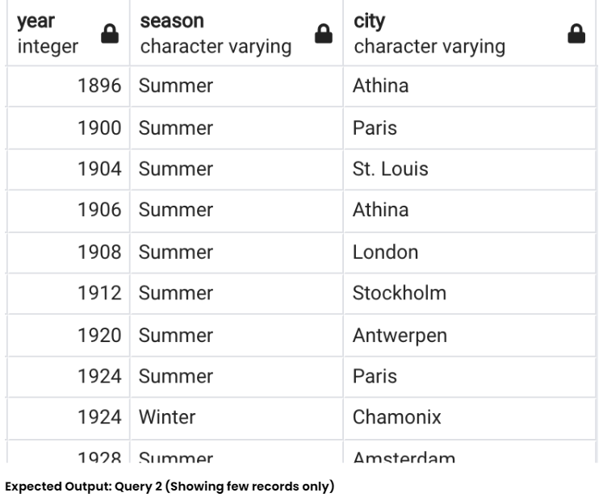

3. Mention the total no of nations who participated in each olympics game?

with all_countries as

(select games, nr.region

from olympics_history oh

join olympics_history_noc_regions nr ON nr.noc = oh.noc

group by games, nr.region)

select games, count(1) as total_countries

from all_countries

group by games

order by games;

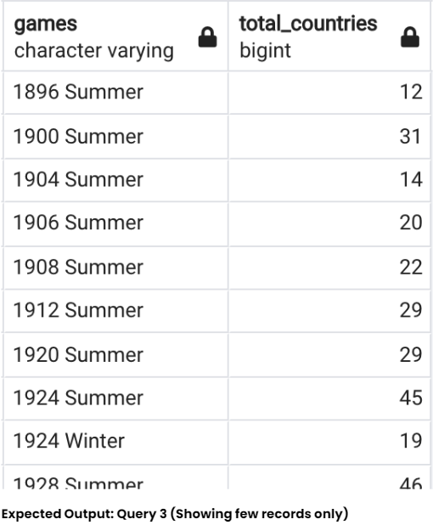

4. Which year saw the highest and lowest no of countries participating in olympics

with all_countries as

(select games, nr.region

from olympics_history oh

join olympics_history_noc_regions nr ON nr.noc=oh.noc

group by games, nr.region),

tot_countries as

(select games, count(1) as total_countries

from all_countries

group by games)

select distinct

concat(first_value(games) over(order by total_countries)

, ' - '

, first_value(total_countries) over(order by total_countries)) as Lowest_Countries,

concat(first_value(games) over(order by total_countries desc)

, ' - '

, first_value(total_countries) over(order by total_countries desc)) as Highest_Countries

from tot_countries

order by 1;

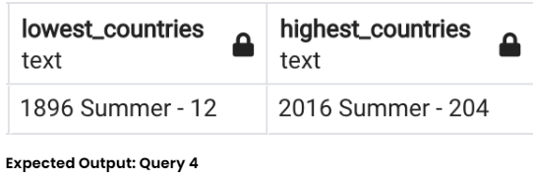

5. Which nation has participated in all of the olympic games

with tot_games as

(select count(distinct games) as total_games

from olympics_history),

countries as

(select games, nr.region as country

from olympics_history oh

join olympics_history_noc_regions nr ON nr.noc=oh.noc

group by games, nr.region),

countries_participated as

(select country, count(1) as total_participated_games

from countries

group by country)

select cp.*

from countries_participated cp

join tot_games tg on tg.total_games = cp.total_participated_games

order by 1;

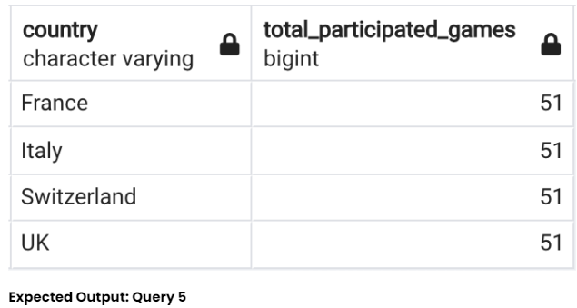

6. Identify the sport which was played in all summer olympics.

with t1 as

(select count(distinct games) as total_games

from olympics_history where season = 'Summer'),

t2 as

(select distinct games, sport

from olympics_history where season = 'Summer'),

t3 as

(select sport, count(1) as no_of_games

from t2

group by sport)

select *

from t3

join t1 on t1.total_games = t3.no_of_games;

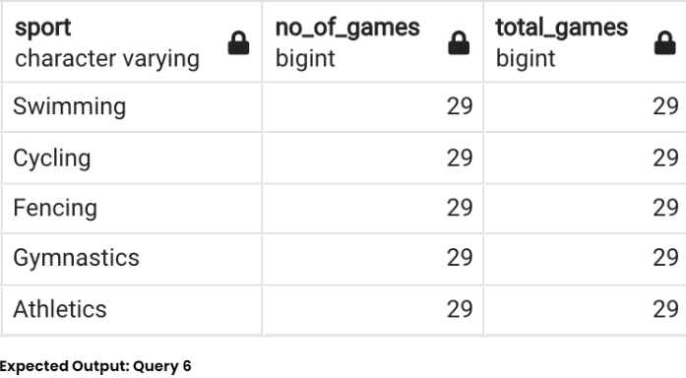

7. Which Sports were just played only once in the olympics.

with t1 as

(select distinct games, sport

from olympics_history),

t2 as

(select sport, count(1) as no_of_games

from t1

group by sport)

select t2.*, t1.games

from t2

join t1 on t1.sport = t2.sport

where t2.no_of_games = 1

order by t1.sport;

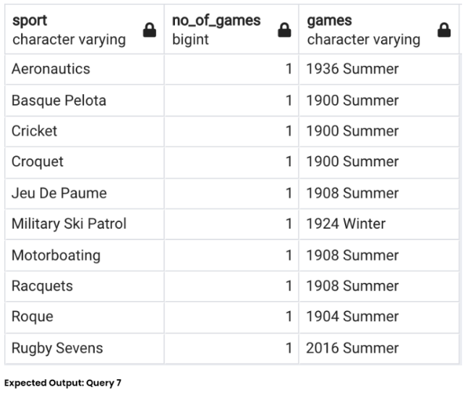

8. Fetch the total no of sports played in each olympic games.

with t1 as

(select distinct games, sport

from olympics_history),

t2 as

(select games, count(1) as no_of_sports

from t1

group by games)

select * from t2

order by no_of_sports desc;

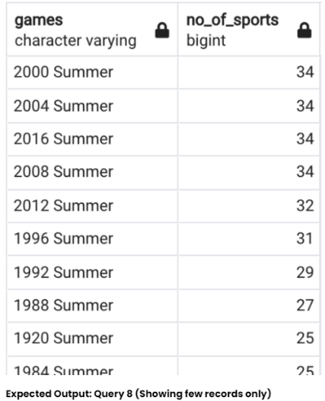

9. Fetch oldest athletes to win a gold medal

with temp as

(select name,sex,cast(case when age = 'NA' then '0' else age end as int) as age,

team,games,city,sport, event, medal

from olympics_history),

ranking as

(select *, rank() over(order by age desc) as rnk

from temp

where medal='Gold')

select *

from ranking

where rnk = 1;

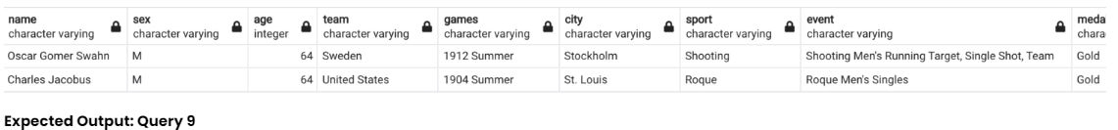

10. Find the Ratio of male and female athletes participated in all olympic games.

with t1 as

(select sex, count(1) as cnt

from olympics_history

group by sex),

t2 as

(select *, row_number() over(order by cnt) as rn

from t1),

min_cnt as

(select cnt from t2 where rn = 1),

max_cnt as

(select cnt from t2 where rn = 2)

select concat('1 : ', round(max_cnt.cnt::decimal/min_cnt.cnt, 2)) as ratio

from min_cnt, max_cnt;

